*****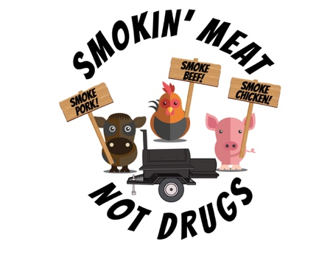Judges’ Application***

*The McShin Foundation’s 16th Annual*

***Recovery Fest and 11th Annual State Championship***

***Barbecue Cook-Off***

***When:*** *Saturday, September 12th, 2020*

*Noon to 5:00PM (Rain or Shine)*

***Where:*** *Hatcher Memorial Baptist Church*

*2300 Dumbarton Road*

*Richmond, Virginia 23228*

**All Applicants (Please Only KCBS Certified Applicants)**

Complete, Sign, and Return This Form Name:   
Address/City/State/Zip   
Home Phone: Cell:   
Email Address: 

Are you a member of the KCBS? Yes

Are you certified as a judge by the KCBS? Yes         If yes, KCBS #: 

CBJ # _________________________

Are you a member of a cooking team? Yes No     If yes, team name: 

***Amendment: When you sign up for this contest, you agree to be part of the Judging process.  The Judging process includes Judging, being a Table Captain, working the Turn-in-Table/Number Changing area and helping at the Leftover area.  If you would like to volunteer in advance for a position other than judging, please indicate that on this application.***

Signature ____________________________________ Date _______________________

Please accept our invitation and call us at 804-249-1845 .Please send application to the McShin Foundation at 2300 Dumbarton Rd. Richmond, VA, 23228.

E-mail us at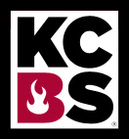 honesty@mcshin.org

**This is a Kansas City Barbecue Society Sanctioned Event**